**PROJECT TOPIC: HAND SIGN RECOGNITION**

**Group No. : 5(3)**

**Project Group Members:**

1. Akanksha Mishra (D-03./181500051.)
2. Sonu Pandey(E-23./181500721.)

**Project Supervisor:** Mr. Saurabh Sighal, Assistant Professor

Mr. Vivek Sharma, Assistant Professor

**About the Project:**

Hand gesture recognition is very significant for human-computer interaction. In this work, we present a novel real-time method for hand gesture recognition. In our framework, the hand region is extracted from the background with the background subtraction method. Then, the palm and fingers are segmented so as to detect and recognize the fingers. Finally, a rule classifier is applied to predict the labels of hand gestures. The experiments on the data set of 1300 images show that our method performs well and is highly efficient. Moreover, our method shows better performance than a state-of-art method on another data set of hand gestures.

**Motivation:**

Some of the major problems faced by a person who are unable to speak are,They cannot express their emotion as freely in this world. Use that voice recognition and voice search features in smartphone(s). Audio results cannot be retrieved. They are unable to use (Artificial Intelligence/personal Butler ) like google assistance, or Apple's SIRI etc because all those apps are based on voice controlling. We will try implementing such an application which detects pre-defined Indian signed language (ISL) through hand gestures.

**Project Planning:**

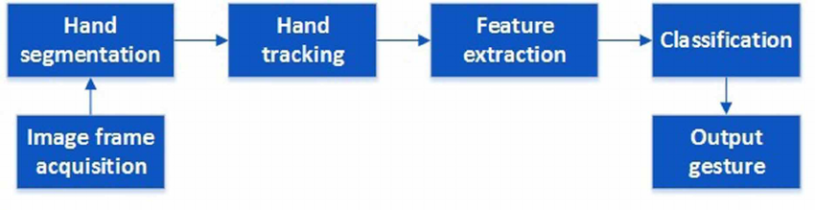

**Tools required:**

* **Hardware Requirements:**i5 Processor ,8GB RAM ,OS
* **Software Requirements:**Python,Open CV

**Signature of Project Guide: _____________________**